**Name:**

**Experiment to investigate the viscosity of different liquids**

**1. Planning**

**Aim** (What are you trying to find out?)

**2. Prediction**

a) **Describe** (What do you think will happen?)

b) Using your knowledge and understanding of science to **explain** why you think this will happen.

**3. Variables (things you change, measure or keep the same in your experiment)**

What will you change, measure and keep the same during your investigation?

|  |  |  |
| --- | --- | --- |
| Variable(s) to **change** – (Independent Variable) | Variable(s) to **measure** –  (Dependent Variable) | Variable(s) to **keep the same** –  (Control Variable) |
|  |  |  |

**4. Fair Test**

**Explain** how you will carry out a fair test – What equipment/features are you going to keep the same? How many times are you going to test?

**5. Method**

In the space below, list the apparatus you will use. Draw a diagram of how you will set up your apparatus if it helps.

Write a step by step plan (almost like a cooking recipe) of how you will carry out this investigation.

**6. Recording & Presenting Data**

1. Results table.

Here is a results table for the data recorded in the video you may have watched (<https://www.youtube.com/watch?v=f6spBkVeQ4w>)

|  |  |
| --- | --- |
| **liquid tested** | **Time (s) for liquid to move down the plate** |
| water | 0.2 |
| milk | 0.3 |
| dish soap | 4.6 |
| corn syrup | 19.5 |
| olive oil | 0.6 |
| maple syrup | 1.3 |
| honey | 20.8 |
| rubbing alcohol | 0.4 |
| lamp oil | 0.5 |

Use the grid below to construct a results table. You do not have to use all the cells. After you have completed your table shade in any cells you do not need.

Remember to include headings and units.

|  |  |
| --- | --- |
| Liquid tested | **Time (s) for liquid to move down the plate** |
|  |  |
|  |  |
|  |  |
|  |  |
|  |  |
|  |  |
|  |  |
|  |  |
|  |  |

1. Graph of results.

On a piece of graph paper, draw a suitable graph of your results. Remember you graph should:

* Have a suitable scale – covers at least half the sheet.
* Have axes clearly labelled with units included.
* Have accurate plots.
* Have a title.

Here is an example from the video you may have watched (<https://www.youtube.com/watch?v=f6spBkVeQ4w>)

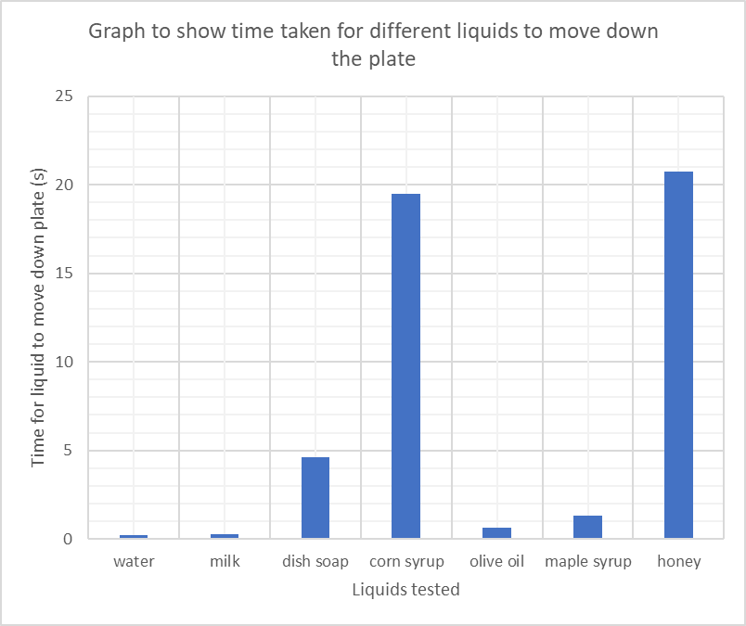

See if you can now draw a similar graph for your data

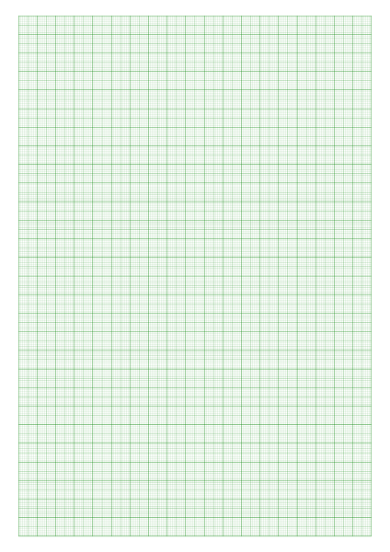

**7. Analysing data and Making Conclusions**

Using your **data**, **describe** any patterns in your results. Think about the time taken for the most/least viscous liquids.

Using your scientific knowledge and understanding, **explain** why this pattern occurred.

**8. Evaluating**

1. Do you think you carried out a fair test? Did you manage to keep your control variables the same?

2. **Suggest** how you could improve your experiment to make it even better if you did it again.